Artificial Neural Network and Deep Learning - Challenge 1

Authors: Flavio Renzi, Jaskaran Singh, Francesco Grilli

# Approach

We started this first challenge together to have a basic understanding of the tools we could use. When we saw the dataset for the first time we immediately noticed that some classes (1st and 6th) were very unbalanced between the others with a ratio of 1:2.7. The majority of the classes could count on several images around 500, so not much data was available for the training. Also, the quality of the images (96x96 pixels) was not very good. We immediately decided to apply some preprocessing stages to our dataset to uniformize the number of images per class and reduce the unbalancing. We have also divided our dataset into three folders (training, validation and testing) to train the model on the training images and check the quality of training over the validation images. The test set was only used at the end of each model to assess the accuracy and compare the quality between different models. To avoid overfitting we have used different techniques. Since we applied oversampling to increase the number of training images, we have also applied a strong data augmentation over the training images on each batch of a different epoch. Looking at the photos already present in the dataset we first decided to apply zoom and rotation since the images were specially made for this kind of transformation, and then we also added shifting and brightness (since some images were dark and with shadows). This brought us better results and a lower discrepancy between training and validation accuracy. Other techniques used for not overfitting were adding the early stopping with a different patience value and a dropout layer with small values (0.1/0.3). To assess the quality of our model we have also used some metrics such as accuracy, recall and loss. All these metrics were measured and averaged between all classes so we also used the confusion matrix to assess the quality of each class. We have understood that the worst accuracy was performed on the 1st class and the 6th, as we could easily expect due to the limited number of images available. A more sophisticated preprocess stage in which we tried to improve the performance was by using the OpenCV library that extracted the plant seedling using only an HSV filter and removed the background noise. Even if we could extract very clear images, we didn’t achieve great results. Starting from these basic techniques we have then developed more advanced ones for improving the preprocessing and the unbalancing of the classes with an overall improvement of the model accuracy. We started the challenge together with a simple network based on VGG16 to try and understand the submission mechanism. At this point, we brainstormed to think of different approaches to face the challenge and we divided the work. Working in parallel allowed us to try different networks and different techniques to solve the classification problem.

## Network from scratch

We start our experiment with different architectures trying to understand how the information is being processed inside the network. In the end, we have done an architecture composed of blocks of filters doubling in depth going in the output direction and interleaving those blocks with an activation layer using ReLU. Experimenting with this network we noticed an interesting property that can help us reduce the number of parameters without changing the network power: the max pooling layer is a max operator between a matrix of input so the max of the output of a monotonic function, in this case, the ReLU, is the function of the max. We used the ReLu layers to add non-linearity and increase the power of the network to represent the information in a more complex way. Going in the output direction we decrease the dimension of a layer but we increase the channel number. In this way, we keep a big receptive field using fewer parameters. With this network, we obtain 0.79 in accuracy on the local test set. The result wasn’t insignificant considering that we had a small dataset but we certainly knew that the key was to use transfer learning to start with a pre-trained CNN and only add the output part.

## VGG16

VGG16 is a very famous CNN used for transfer learning. The fundamental idea is similar to our approach when we build our network from scratch. Use a sequence of blocks of filters increasing in depth to expand the output receptive field. Those blocks are interleaved with a Max Pooling layer of 2x2 to reduce the layer size going down the network. In our experiment we instantly noticed that, as we expected, increasing the number of dense layers in output led quickly to overfitting, having a training accuracy skyrocket to 0.95+ and the validation accuracy remaining low around 0.60. We settle on just one dense layer followed by the output layer with a softmax activation function and we start working on the data with oversampling and aggressive data augmentation without success. We also applied fine-tuning by trying different numbers of layers to unlock during this phase, understanding that with a dataset where the features are really difficult to find it is better to unlock almost the whole network and use a slow learning rate. The best result we had with this network was with a basic augmentation and oversampling just to balance the classes and pushing a little bit the dropout after the CNN with an accuracy of 0.83 in our local test and a 0.81 when submitted on Codalab.

## ResNet

The main idea of moving from the most regular VGG16 network to the ResNet was to use a smaller network, less number of filters and with fewer parameters. The characteristics of this network are the “shortcut connections” between different blocks of convolutional layers. Also, ResNet uses a bottleneck design for the building block that reduces the number of parameters and the number of multiplications, making the training of the network faster. This feature and the fact that the network has fewer parameters allowed us to fine-tune the entire network, not overfit and achieve good results. After many trials, in fact, we have achieved the best result using basic augmentation and balancing the classes with an accuracy of 0.83 on our local test and 0.79 on the Codalab hidden tests. The worst classes still remained the 1st and the 6th with an accuracy of around 0.6.

## EfficentNet

This is the biggest network we tried. It is a very versatile network existing in various versions because the core principle is that it can uniformly scale to a different width, depth or resolution based on a coefficient. The ability to scale means that it can be used in different types of hardware without the need for a powerful GPU if needed. The smaller version of it is based on MobileNetV2 which also uses the concept of shortcuts similar to ResNet. Given the dimension of the network, we didn't do anything fancy with the output layers.

We tested different numbers of layers to unlock during the fine tuning phase and we observed that unlocking more than half of the network was pretty useless and led to overfitting. In the end, we obtained an accuracy of around 0.80 on our local test and we see little to no difference despite our changes and efforts.

## XceptionNet

XceptionNet was born as the evolution of InceptionNet. It differs from the other network we have tried because it introduces a new type of layer called Depthwise Separable Convolution which first applies the spatial convolution to each channel and then a pointwise convolution to obtain the result. It differs from the standard convolution because we don't need to compute the filter across all input channels, reducing the number of parameters used.

The main difference with respect to the InceptionNet, apart from the swap of the order between the depthwise convolution and the pointwise convolution putting the last one before, is the absence of an intermediate ReLu to add non-linearity. From our experiment, we obtain the best result with a single big dense layer before the softmax. We have tried different types of data augmentation but in the end, we have used an aggressive dropout (0.4) to prevent overfitting. We didn't see big evidence of overfitting so we decided to unlock the whole network during the fine-tuning phase obtaining our best result with an accuracy of 0.89 in our local tests and 0.87 when submitted on Codalab.

# Major failures (and what we learned from them)

## HSV filtering

As said before, one technique we have implemented for preprocessing our dataset was to extract the plant seedling only and remove the background that we have considered noise. In this way, we have obtained images with very clear plants on a black background. The technique was based on HSV values, keeping only green HSV and removing the rest. The final result were images with very clear plant seedlings in the foreground but with a very portion of the plants, the main part of the images were black and classified as noise. The results of this preprocessing were bad, with an accuracy of 0.4.

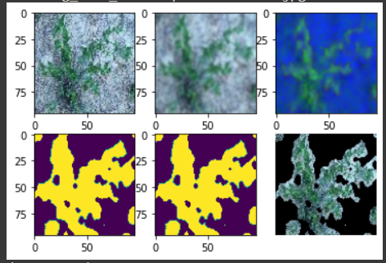 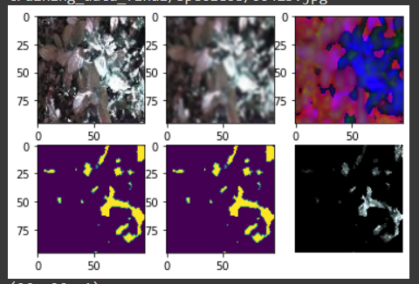 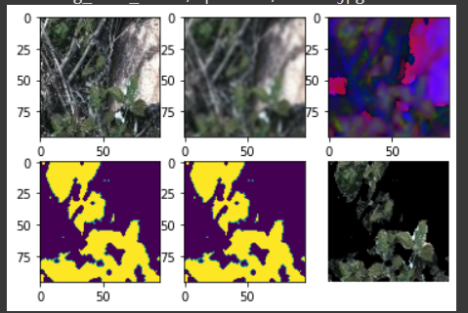

Output of each layer of the HSV filter implemented

(Input image, gaussian blur, HSV map, generated mask, boolean mask, output image)

As we can see from these examples, sometimes, this method works really well but, in other cases, it generates an almost black image so we thought that the problem was that the filtering was too aggressive, it removed too much from the images. Also, we thought that our model could not extract features with black portions of images that were not all in the same place, but changed position every time.

An idea we had is to use this filter as part of the network to add a fourth channel to the input with the mask so that the network can figure out by itself when to use the mask and when to discard it. We tried to implement this method, but after a lot of work, we couldn’t finish it in time for the end of the project.

## Class 1 vs the World

Looking at the result we had with the traditional convolutional network, it was clear that we were struggling in the first class, the one where we had the least data.

To try to overcome this issue we decided to create a classifier that can distinguish only the first class from the others. Our idea was that in this way the network doesn’t have to learn what is class 1, but actually what it isn’t. In this way, we can use a lot of data from the other classes to do this. We learned the hard way that this was a terrible idea because we actually accentuate the problem of the unbalanced classes so much that also the oversampling cannot keep up with it. This idea was not discarded entirely because in our best network we revised this method to work in combination with other networks.

# Best Result

At the end of the competition we had a model based on XceptionNet that scored 0.87 in accuracy on Codalab, but we know that the results on the first species were what held us from achieving better results.

We had already tried different methods of augmentation and other techniques to improve our results in that class but when we had a model that performed well in that class, it was terrible in the others.

to take the best of both worlds we use a technique called ensemble method to join two or more models together. We started training a model doubling the weight of the first class to make it worth more than the others. Then at first we just run the 2 models in parallel and at the end, we take the more confident class from the two and we use it as output. In this way, we achieved a little improvement so we tried combining the 2 networks with a simple softmax layer. This led us to our best results, with an improvement on the single models of 2 percentage points in the overall accuracy and almost 12 percentage points in the score of the first class. At the end of the competition, with this method, we reach an accuracy of 0.887 in the final hidden test. Overall, we are very pleased with the results of our competition entry. We believe that our approach of using an ensemble of two different models was key to our success. We believe that there is still room for improvement and for learning.